Extratropical Transition in the Southwest Indian Ocean
Kyle S. Griffin and Lance F. Bosart
Department of Atmospheric and Environmental Sciences
University at Albany/SUNY, 1400 Washington Avenue, Albany, NY 12222

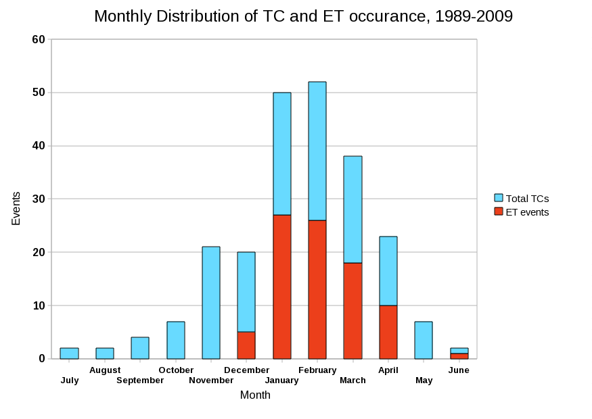
Tropical cyclones (TCs) in the Southwest Indian Ocean (SWIO) are relatively unstudied, likely because of the relatively small human population impacted by them. Preliminary results of a basin-wide climatological analysis of both TCs and extratropical transitions (ETs) during 1989-2009 show that ~38% of the 233 observed SWIO TCs undergo ET, a similar rate as TCs in the Atlantic and Northwest Pacific basins. SWIO TCs undergo ET most frequently in January and February (Fig. 1). While the vast majority of TC activity occurs from mid-November through mid-April, ET events are more likely to occur in the later of these months.
Figure 1: Monthly distribution of TC and ET events over the period 1989-2009. Months progress from July (left) to June (right) in accordance with the Southern Hemisphere TC season. 88 of 233 TC events undergo ET.

The strongest TC post-ET reintensification observed occurred with Edisoana (1990). Common to many recurving TCs in the SWIO, Edisoana underwent ET while accelerating poleward and reintensifying as an extratropical cyclone (EC). Although post-ET reintensification is nothing unusual, Edisoana achieved a minimum central pressure of 935 hPa as an EC and was the most intense EC observed in the SWIO ET climatology. The rapid reintensification of Edisoana as an EC is partially attributable to its baroclinic interaction with a pair of upper-level disturbances that originated at Antarctic latitudes. The more significant factor in Edisoana’s rapid reintensification as an EC was the phasing of a ridge in the subtropical jet stream and a ridge in the polar jet stream, driven by strong diabatic heating immediately downstream of the cyclone. This phased ridge, while not allowing for a complete phasing of the upstream troughs, provided a favorable environment for baroclinic growth as the downstream wavelength between the upstream troughs and the downstream phased ridge shortened. Both of these attributions can be understood via the potential vorticity (PV)-thinking methodology as well.
Following a brief discussion of the SWIO TC/ET climatology, an examination of Edisoana’s evolution both during and after ET will be presented. The ECMWF Interim reanalysis was utilized for this work due to its generally superior analysis of satellite data over remote regions such as the data-sparse SWIO. An investigation of the formation of the phased ridge feature downstream of Edisoana will tie into a discussion of the troughs that allowed for such a rapid deepening of the surface EC. A schematic of the key processes in play will also be presented in hopes to increase forecaster and researcher awareness of potential phased-ridge development in other TC basins worldwide.

